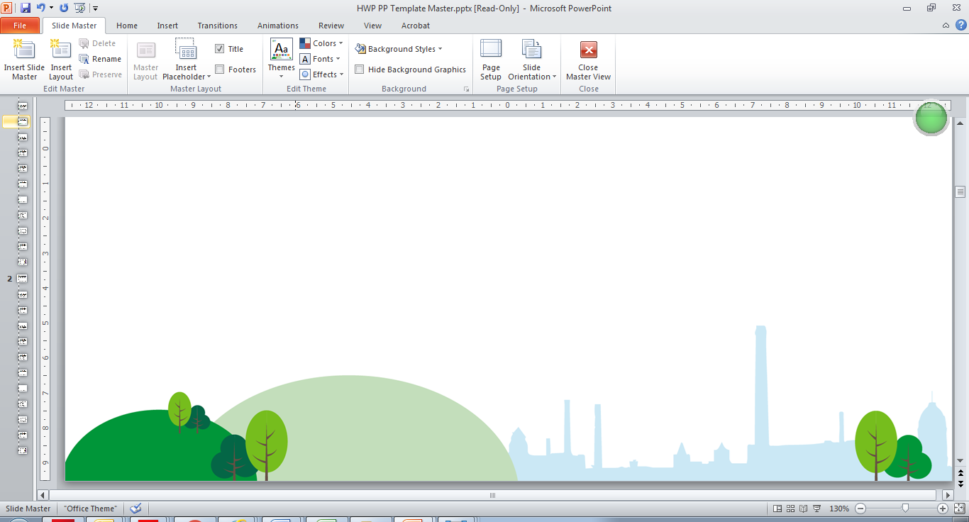

To help keep you safe, you can no longer walk into your GP practice or book an appointment online.

You’ll need to contact your practice via telephone and answer some questions.

Please be patient, these new measures will help us keep staff and patients safe during this time.

The majority of conversations with a GP or nurse are now being done via telephone or video calls. If you do need to be seen in person your practice will arrange this with you.

Please be kind to your GP practice, they are working hard to get us through this!

#BeKind #Coronavirus #COVID-19

GP Practices are working differently

