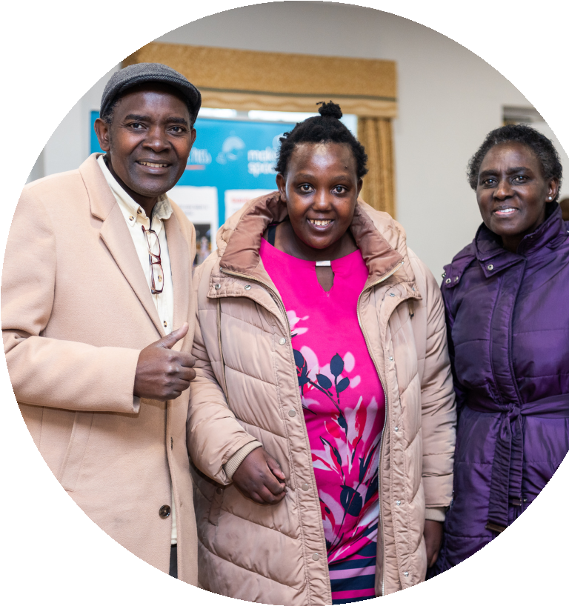
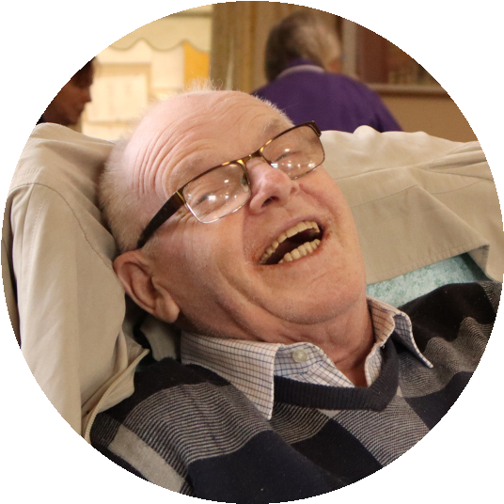
Psychological Wellbeing Service
A FREE NHS Funded step 2 Cognitive
Behavioural Based Therapy Service
Are you feeling low, anxious, overwhelmed or stressed?
Don't struggle alone.
Our friendly psychological wellbeing team are
here to help.
How do I access the service?
Contact us today to find out more information about the services we provide:
masp.wellbeing@nhs.net 01925 581 755
Our services are available to anyone who is aged 16+ and registered with a GP in the Wigan area.

